1. Delete the Old Task (for the SO Pick Release)
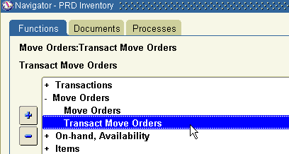

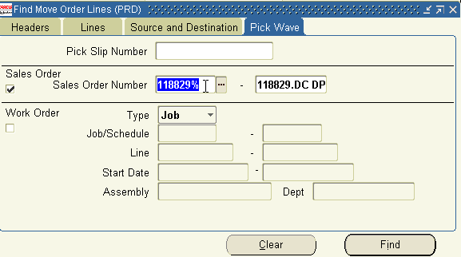

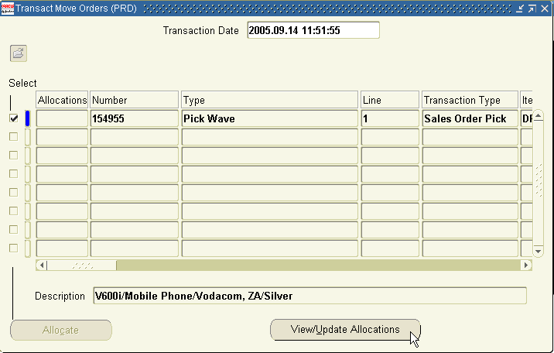

At next screen, delete the records. (will delete the Task)
Then re-allocate the move Order, will create a new task.

